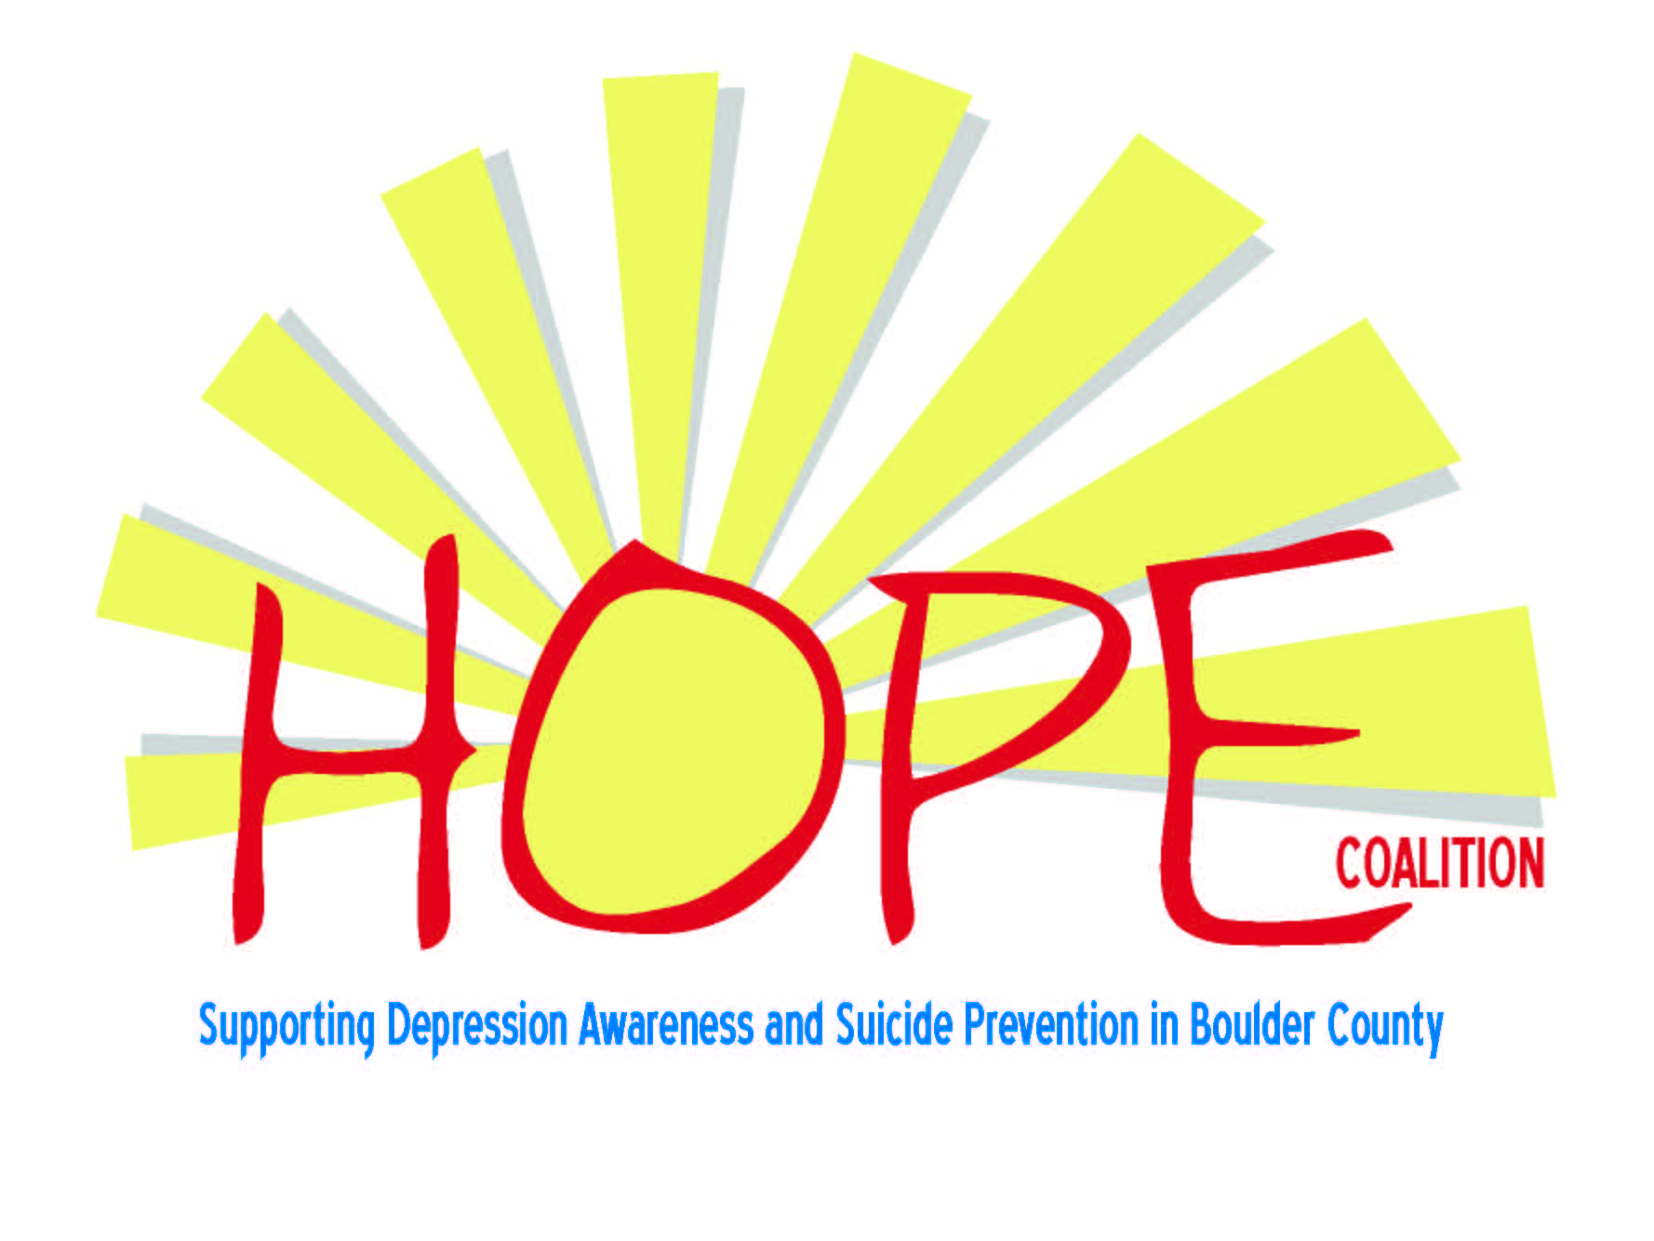

**Supporting Depression Awareness and Suicide Prevention in Boulder County**

**HOPE Lights the Night**  
**Eighth Annual Candlelight Gathering   
 Remembering Those Lost to Us by Suicide**

**Honoring the Bereaved and All Touched by Suicide**

Wednesday, November 9th at 7 p.m.  
*Non-Denominational event at the*  
Community United Church of Christ  
2650 Table Mesa Drive in Boulder

This free program includes music provided by Resonance Women’s Chorus, Sue Coffee Director, and Cantorial Soloist Holli Berman, responsive readings,   
a symbolic lighting of candles, and brief comments   
about how suicide affects us all. Refreshments will   
be provided after the program.

Bring a picture of your loved one to post, if you like.

Information about depression, suicide, mental health,   
and local resources will be available.

OrganizedbyThe HOPE Coalition and sponsored by many community partners

*For more information, contact* *Susan Marine*

Swdkm321@comcast.net  
**www.hopecoalitionboulder.org**